CST2572 Group Coursework Contribution Sheet
Student Name | Student ID | Role/Responsibility | Tasks Completed (give details of your contribution not just bullet points) | Comments / Notes
Rushill Reuban | M00985349 | Managing the assignment and making sure everyone understands and is clear about their parts and task; also worked on case study, readme file and editing the video. | Patient, case study, ER diagram, database, README, video editing.  Developed patient, and edited the project video, and assisted with the database and ER diagram. | Worked closely with the team throughout the project, coordinating tasks and ensuring everyone understood their roles. Managed the overall progress
Mohammed Farhaan | M01034338 | Making sure there is logic in the code and making it modular according to the webpage and database also worked on the case study and readme file and planning the video content. | login, patients, doctor, admin, database, README and case study.  implemented and tested the authentication system, and developed, admin, patient and doctor pages as well the database. And debugging other aspects of the webpage. | Worked in the creating functions and debugging everything, helping everyone with there’s challenges and put everything together for the final submission.
Aneeq | M00985227 | Helped with the research for the case study and worked on the frontend of the webpage giving a lot of ideas. | doctor, patients, homepage, and case study.  Developed the doctor pages and built the main index page. Contributed to writing the case study and worked with the team on development and testing pages. | Worked closely with the team throughout, contributing to key frontend. Helped with testing and made sure everything came together smoothly.
Murtaza | M01040474 | He gave his ideas and logic for the ER diagram to help with the database and also he helped with the video making while working on the case study aswell as constructing the admin page | admin page, ER diagram, database, and case study  Developed admin page. created the ER diagram to show how our database was structured. Helped write the case study and assisted with testing different parts of the project | Contributed to database design and admin. Worked well with the team and helped document the project through the case study and video.

Summary of Group Contribution:
(Briefly describe how the group collaborated and ensured fair contribution)

Signatures:
Name | Signature | Date
Rushill Reuban |  | 11/8/2025
Mohamed Farhaan |  | 11/8/2025
Murtaza Shahid |  | 11/8/2025
Aneeq Khan | 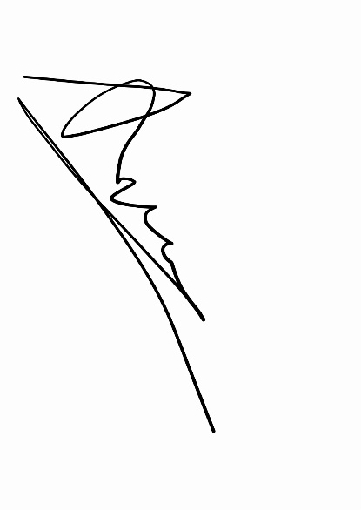 | 11/8/2025

